Pre Calc Name: ______________

______________ ______________

WS Assessment

Target 20

The limit

* The Limit Laws
* Evaluating Limits
* Continuity and Discontinuity

HW 20 Limit deltamath.com

*Limits*are a mathematically precise way of representing how a function acts when its independent variable is close to a certain number.

For instance, the function $f\left(x\right)=\frac{x^{3}-{4x}^{2}+x+6}{x^{2}-5x+6}$ does not have a value at x = 2. In order to find this value we do find the limit of function as x goes very close to 2. We write ?_______________

Two Special Limits Basic limit laws

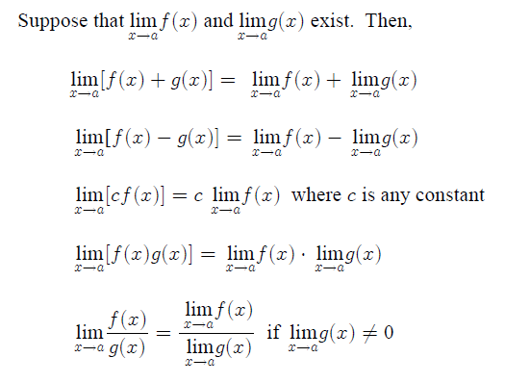*Limit of a Constant Function*

$$\lim_{x→a}{c=c}$$

*Limit of the Identity Function*

$$\lim_{x→a}{x=a}$$

Find the following limit

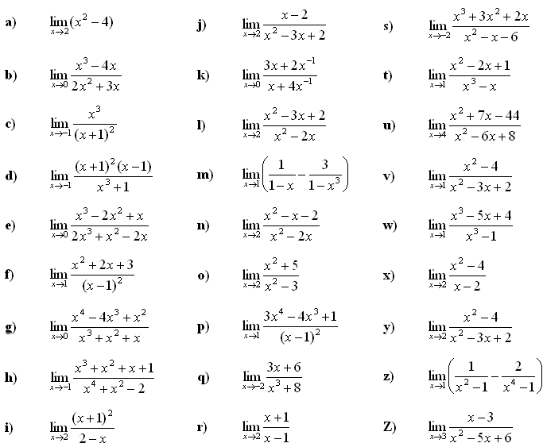

Limit of Summations Review Summation formula

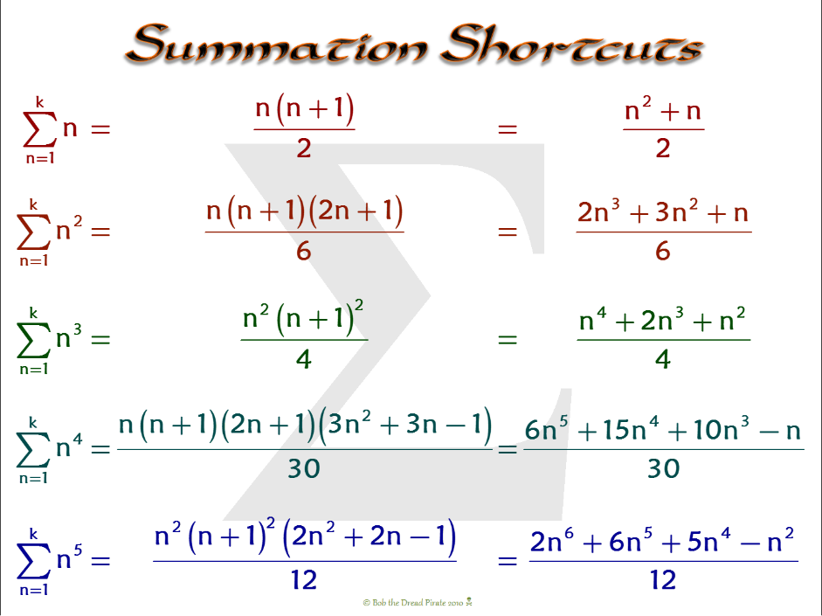

Rewrite the series and evaluate the following

|  |  |  |
| --- | --- | --- |
| $$\sum_{n=1}^{200}{n=}$$ | $$\sum_{n=1}^{100}{n^{2}=}$$ | $$\sum_{n=1}^{50}{n^{3}=}$$ |
|  |  |  |

Given S(x) as follow, find the limit of S(x) as x 🡪 ∞

Find the area of the region bounded by the graph of f(x) = x2 and the x-asis between x = 0, x = 1 by using sum of all the rectangle

Continuity and Discontinuity. Functions which have the characteristic that their graphs can be drawn without lifting the pencil from the paper are somewhat special, in that they have no funny behaviors. The property which describes this characteristic is called continuity.

A function f(x) is **continuous at a point** where x = c   when the following three conditions are satisfied.

* The function exists at x = c. In other words, f(c) is a real number.
* The limit of the function exists at x = c. That is, $\lim_{x→c}{f(x)}$ is a real number.
* The two values are equal. That is $\lim_{x→c}{f(x)}=f(c)$

Type of discontinuity

|  |  |  |  |  |
| --- | --- | --- | --- | --- |
| Infinite | Removable | Jump | Essential | Mix |
| https://www.math.hmc.edu/calculus/tutorials/continuity/gif/figure1.gif | https://www.math.hmc.edu/calculus/tutorials/continuity/gif/figure2.gif | https://www.math.hmc.edu/calculus/tutorials/continuity/gif/figure3.gif | https://www.math.hmc.edu/calculus/tutorials/continuity/gif/figure5.gif | Mixed Discontinuity |





Use the definition of continuity, determine whether the graph of $f\left(x\right)=\frac{x^{3}-4x}{x^{2}+8x-20}$ is continuous at the following. Justify

x = 2 x = 0 x = -10

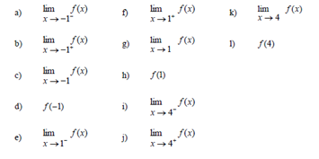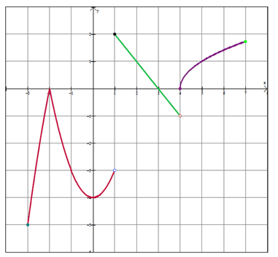Given f(x) as seen, find the following

Write the piecewise function for this graph and graph to stamp

Now consider the piecewise function $f\left(x\right)=\left\{\begin{matrix}\begin{matrix}kx-3, & x<1\end{matrix} \\ \begin{matrix}{-x}^{2}+3x+5, & x≥1 \end{matrix}\end{matrix}\right.$

State the value of k to make this function continuous.

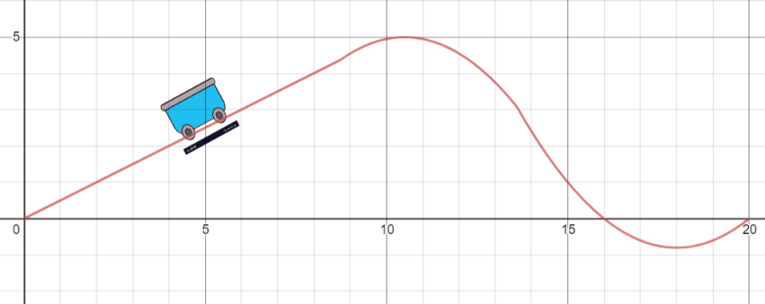Design a roller coaster function similar to this for stamp

**Target 20 Assessment**

For $f\left(x\right)=\frac{x^{2}+x-20}{x^{2}-16}$, algebraically determine the following

f(4) $\lim_{x→4^{-}}{f\left(x\right)}$ $\lim_{x→4^{+}}{f\left(x\right)}$

$\lim_{x→-1}{f(x)}$ $\lim_{x→0^{-}}{f(x)}$ $\lim_{x→1}{f(x)}$

Use the definition of continuity, determine whether the graph of $f\left(x\right)=\frac{x^{2}+x}{x^{3}+2x^{2}-3x}$ is continuous at the following. Justify

x = 0 x = 1 x = 2

Let $f\left(x\right)=\left\{\begin{matrix}\begin{matrix}\sin\left(x\right), x<0 \\ x^{2}, 0≤x<1\end{matrix} \\ 2-x,1≤x<2 \\ x-\frac{50}{24},x≥2\end{matrix}\right.$

Sketch this graph (show screen for stamp) . Find what values of x is f(x) NOT continuous, explain why.